***LEADERSHIP POINTS TO NOTE:***

What is a Leader?

John Adair’s matrix

1. Leader should have 3 motives **People - System - Vision**
2. People - Leaders job is to identify right people to do the job so that he is HANDS OFF.
3. System - He should have a system/processes in place which run by themselves
4. Vision - He should have a vision as to where the company is heading.
5. 5 types of Communication that can be done to pass the message to the team
6. Floor Walk and communicate with workers (Management by walking about) - To understand the problems they have
7. Do the job once in a while yourself (Back to the floor) - To understand workers problem on ground
8. Information Cascade - Written communication, or banners or technology etc
9. Team Meeting - Weekly meeting at all levels Whether required or not it should be there. It gives a platform to share common stuff, workers discover what others are working on and might discover that they are working on the same which someone else is working. Team meeting platform is important for all these discoveries
10. Addressing the troops – Troops want to see whole team in one room. Pass on information such has how we performed last year, What is our vision for coming year etc.

**COMMUNICATION IS THE ESSENCE OR FUNDAMENTAL OF LEADERSHIP. IT SHOULD BE DONE IN PLENTY**

*MOTIVATION***:**

1. Is Leadership Born or Made?
   1. What matters is what YOU DO rather than what trait you have
   2. John Adair leadership style. Each stage in leadership look into 3 areas – Task, Team, Individual.
      1. *Action Based leadership***:** Following are the stages
         1. Objectives
         2. Planning
         3. Briefing
         4. Action
         5. Review
2. **Maslow’s hierarchy of Needs in a Leadership Role**

It’s a pyramid starting from point a below till e, a being the base. If the below levels are not met the pyramid will crumble. So each stage in the hierarchy starting from “Psychological need” has to be met before the next stage can be provided else the pyramid will crumble.

* 1. Psychological need (Survive) – Basic necessity should be sufficed (Food, water, warmth rest)
  2. Safety Needs (Security) – Security, Safety. In IT context, job security.
  3. Social – Giving a platform of being social with the team etc. E.g. can be team activities
  4. Esteem/Ego & Status – Giving an opportunity to say “I made that…”. Giving them ownership of something
  5. Self-Actualization (Self-Fulfilment) - Achieving one’s full potential, including creative activities. Giving a platform for them to prosper and to perform at max of their potential.

1. **4 Types of People:**

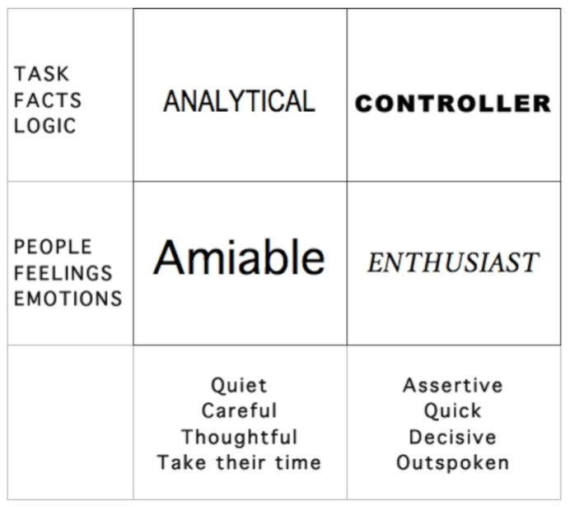

1. **20 Motivational Tips:**
   * + 1. Give everyone ownership of something
       2. Involve people as much as possible in decisions
       3. Give everyone a challenge
       4. Let people set their own objectives
       5. Do regular appraisals
       6. Provide security - give information, be consistent
       7. Give lots of praise and encouragement
       8. Thank people - everyone at least once a week
       9. Coach rather than criticize
       10. Know what motivates each unique person
       11. Offer constant learning
       12. Give individual progress goals, and team ones
       13. Involve people in their own development plan
       14. Are people fulfilling their potential?
       15. Give people time to talk to you
       16. Keep tasks novel and interesting
       17. Create a sociable environment
       18. Build a team ethos and feeling
       19. Make money a reliable constant
       20. Set a role model example

*DELEGATION:*

1. **8 Steps for delegating:**
2. What you want - clearly. It is very important that you community your goals and expectations from the work. Otherwise they will deliver something “wrong” and it will be your fault.
3. Why it is an important job - big up the job and how it’s important to you and an honour for them. You trust them and are proud of the work they have done so far. If they do this job well it will be a huge help to you and the company.
4. Why them - explain that you want them to be the expert on this in future and this is the first step. They have been doing a great job so far so you want to reward them with more responsibility.
5. What are the limits? - when you do need it by and how much can they spend. Can they use other employees, or other resources too?
6. Reporting process - how often should they check in with you, and what form (email/in person/formal report document, etc).
7. Offer support - tell them they can always come to you with questions or difficulties. They needn’t be scared to ask questions and they won’t get in trouble or be ashamed. You know it’s something new so you are happy to help and are expecting questions.
8. Are you OK? - double check they are confident with the brief and are happy to start the work. They shouldn’t have secret questions or fears. If they seem vague or nervous then drill down with some follow up questions of “what will be your first step”
9. Go and do it - off they go to be a wonderful employee!
10. **Freedom Ladder:**

